Cameroon

## Respect for rule of law (ROL) data

The data set shows the data on the respect of the rule of law for the country.

## # A tibble: 19 x 5  
## country iso3c date ruleOfLaw ruleOfLawCategory4   
## <chr> <chr> <dbl> <dbl> <chr>   
## 1 Cameroon CMR 1996 -1.44 ROL highly disrespected   
## 2 Cameroon CMR 1998 -1.07 ROL highly disrespected   
## 3 Cameroon CMR 2000 -1.20 ROL highly disrespected   
## 4 Cameroon CMR 2002 -1.23 ROL highly disrespected   
## 5 Cameroon CMR 2003 -1.08 ROL highly disrespected   
## 6 Cameroon CMR 2004 -1.19 ROL highly disrespected   
## 7 Cameroon CMR 2005 -1.21 ROL highly disrespected   
## 8 Cameroon CMR 2006 -1.15 ROL highly disrespected   
## 9 Cameroon CMR 2007 -1.18 ROL highly disrespected   
## 10 Cameroon CMR 2008 -1.10 ROL highly disrespected   
## 11 Cameroon CMR 2009 -1.12 ROL highly disrespected   
## 12 Cameroon CMR 2010 -1.07 ROL highly disrespected   
## 13 Cameroon CMR 2011 -1.07 ROL highly disrespected   
## 14 Cameroon CMR 2012 -1.04 ROL highly disrespected   
## 15 Cameroon CMR 2013 -1.05 ROL highly disrespected   
## 16 Cameroon CMR 2014 -0.896 ROL moderately disrespected  
## 17 Cameroon CMR 2015 -0.975 ROL moderately disrespected  
## 18 Cameroon CMR 2016 -1.04 ROL highly disrespected   
## 19 Cameroon CMR 2017 -1.02 ROL highly disrespected

## Respect for rule of law (ROL) trend

The plot shows the trend of the respect for the rule of law for the country.

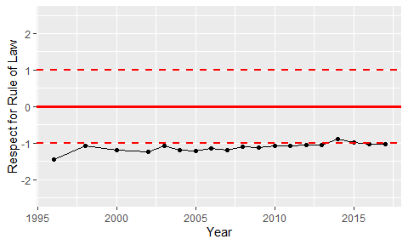

Trend of the Respect for the Rule of Law